 | 26.6 Editors - Properties Editor - World Properties Tab
Table of content
World Tab 3
Render Engine 3
World Data Prop 3
World Browser 3
World Edit Box 3
Fake User 4
New 4
Remove 4
Viewport Display - All Renderers 4
Color 4
Animate Property 4
Custom Properties Panel - All Renderers 4
Add 4
Edit 4
Remove 4
Surface Panel - Eevee and Cycles 4
Use Nodes 5
Color without nodes 5
Surface 5
Cycles - Preview Panel 6
Eevee and Cycles - Volume Panel 6
Cycles - Ray Visibility Panel 6
Camera 6
Diffuse 6
Glossy 6
Transmission 6
Volume Scatter 6
Cycles - Settings Panel 7
Surface 7
Sampling 7
Map Resolution 7
Max Bounces 7
Shadow Caustics 7
Volume 7
Sampling 7
Interpolation 7
Homogeneous 7
Step Size 7
Light Group subpanel 8
Cycles - Ray Visibility Panel 8
Camera 8
Diffuse 8
Glossy 8
Transmission 8
Volume Scatter 8
Eevee - Settings Panel 8
Light Probe subpanel 9
Resolution 9
Sun subpanel 9
Threshold 9
Angle 9
Shadow subpanel 9
Shadow 9
Jitter 9
Overblur 9
Filter 9
Resolution Limit 9

World Tab

The world tab provides you with world settings. Like Viewport Display color. The content vary, dependent of the chosen renderer.
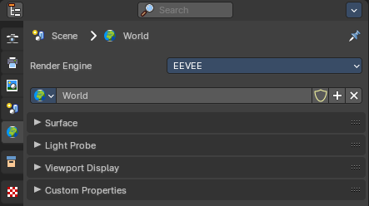
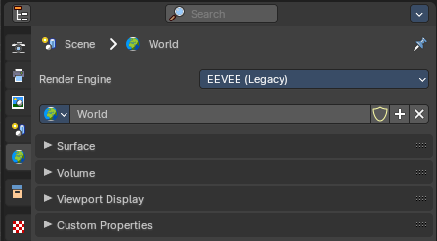

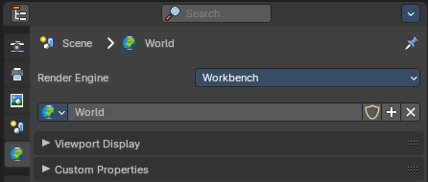
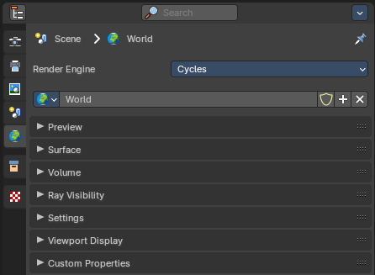

Render Engine
Shows the active render engine. Specific renderer does have other settings. And you can also switch to another renderer. But note that this is more a visual guide. It misses the Cycles render settings.

World Data Prop
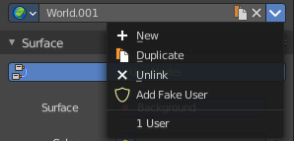

Here you can manage and change your world settings. There can be more than one World.

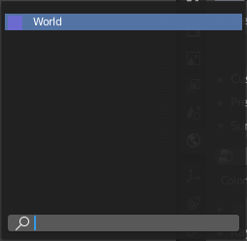
World Browser
Here you can see and choose your world files.

World Edit Box
Here you can see and change the name of the current world file.

Fake User
When enabled then this world file will be stored internally. And will remain in the scene.

New
Create a new world file.

Remove
Note that this just sets the World file inactive. It is still in the list. You can delete the world file when it has no user anymore by saving the scene, closing and reopening Bforartists.

Viewport Display - All Renderers

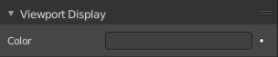
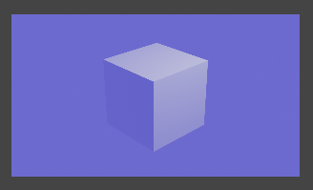
Color
The color that you can choose here is the background color for rendering the image.

Animate Property
This property can be animated. Activating this button sets a keyframe.

Custom Properties Panel - All Renderers

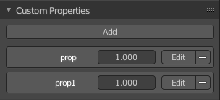
Here you can define custom properties that can be used for scripting.

Here you might also find custom properties from addons or scripts.

Add
Adds a new property.


Edit
A panel where you can adjust the settings for the custom property.

Remove
Removes the property.

Surface Panel - Eevee and Cycles

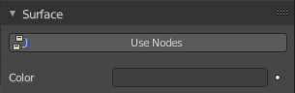
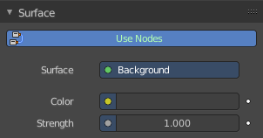
Use Nodes
Use Nodes or simple background color.
When you use Nodes then you will reveal further options.
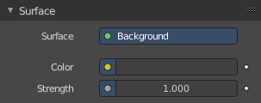
Note that Cycles misses the Use Nodes button once you have activated the nodes.

Color without nodes
The color that you can choose here is the background color for rendering the image.

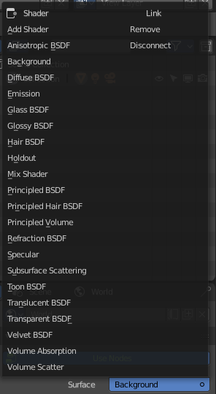
Surface
Here you can choose what shader you want to use for the background. Usually the Background shader. But you can use any shader in the list here too.
The options below changes dependent of the shader that you choose. They are explained in the shader editor chapter.
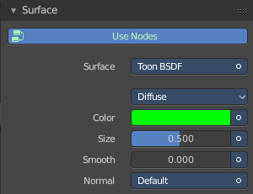
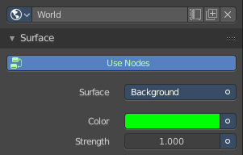

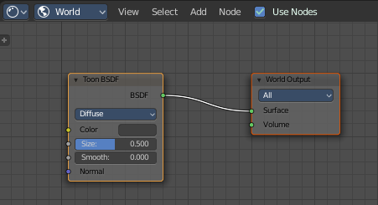

Cycles - Preview Panel
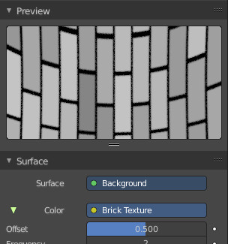
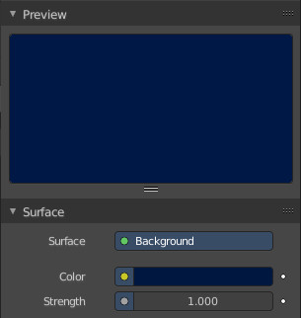
The Preview panel gives you a preview of the background color.

The color can also be an image. This depends of what you have chosen for the color method in the surface panel.

Eevee and Cycles - Volume Panel

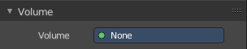
Volume rendering is a method to render light as it passes through a media within a 3D region. Here you can choose a shader for volume rendering.

Cycles - Ray Visibility Panel

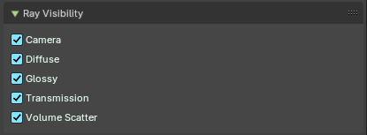
Adjust the ray visibility.

Camera
Object Visibility for Camera rays.

Diffuse
Object Visibility for Diffuse Reflection rays.

Glossy
Object Visibility for Glossy Reflection rays.

Transmission
Object Visibility for Transmission rays.

Volume Scatter
Object Visibility for Volume Scatter rays.

Cycles - Settings Panel
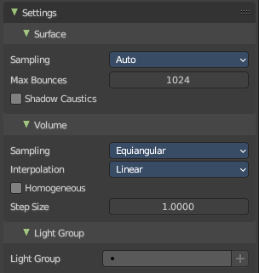

Surface

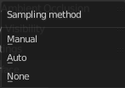
Sampling
Here you can choose the method for the surface sampling.

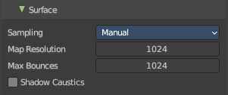
Map Resolution
Just with method manual. Adjust the map resolution manually.

Max Bounces
Maximum number of bounces the background light will contribute to the render.

Shadow Caustics
Generate caustics in the shadows of refractive surfaces.

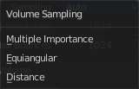
Volume

Sampling
Here you can choose the volume sampling method.

Interpolation
Here you can choose between cubic and linear interpolation.

Homogeneous
When using volume rendering, assume that the volume has the same density everywhere.

Step Size
Distance between volume shader samples when rendering the volume. Lower values increases accuracy and render time.

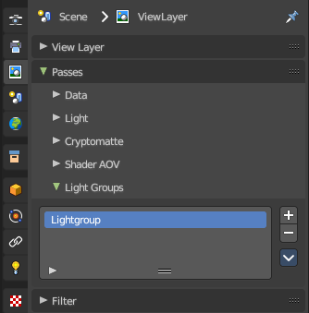
Light Group subpanel
Manage the light groups that you want to use in the world settings.
Light group allows you to save light settings into layers. This enables you to adjust the lighting afterwards in compositing for example.
You need to have a lightgroup in the scene. You create them in the View Layer Properties tab in the Passes panel in the Light Grups supb panel.

Cycles - Ray Visibility Panel

Adjust the ray visibility.

Camera
Object Visibility for Camera rays.

Diffuse
Object Visibility for Diffuse Reflection rays.

Glossy
Object Visibility for Glossy Reflection rays.

Transmission
Object Visibility for Transmission rays.

Volume Scatter
Object Visibility for Volume Scatter rays.

Eevee - Settings Panel
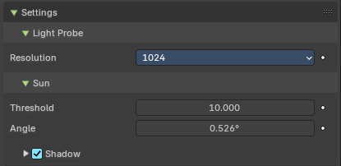

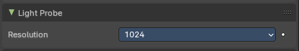
Light Probe subpanel

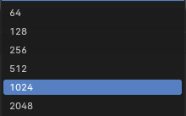
Resolution
The resolution when baked to a texture.

Sun subpanel

Threshold
The maximum value of the world contribution that will be recorded inside the light probe. The excess contribution is converted to a sunlight. A value of zero disables the feature.

Angle
Angular diameter of the sun as seen from the earth.

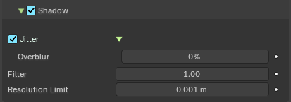
Shadow subpanel

Shadow
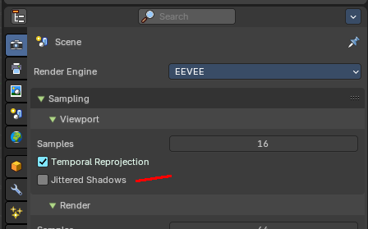
Enable sun shadow casting.

Jitter
Enable jittered soft shadows to increase precision in the final rendering. This feature is disabled in the viewport settings by default. And can be activated for the viewport in the render settings.

Overblur
Apply shadow tracing to each jittered sample to reduce under-sampling artifacts.

Filter
Blur shadow antialiasing.

Resolution Limit
Maximum size of a shadow map pixel. Lower values gives higher resolution and better quality.

